Obfuscation Metric

F- Failing nodes using formal verification

Fi – fanin cone size

Sn- Failing state elements

Obfuscation Metric derived as in the below picture:

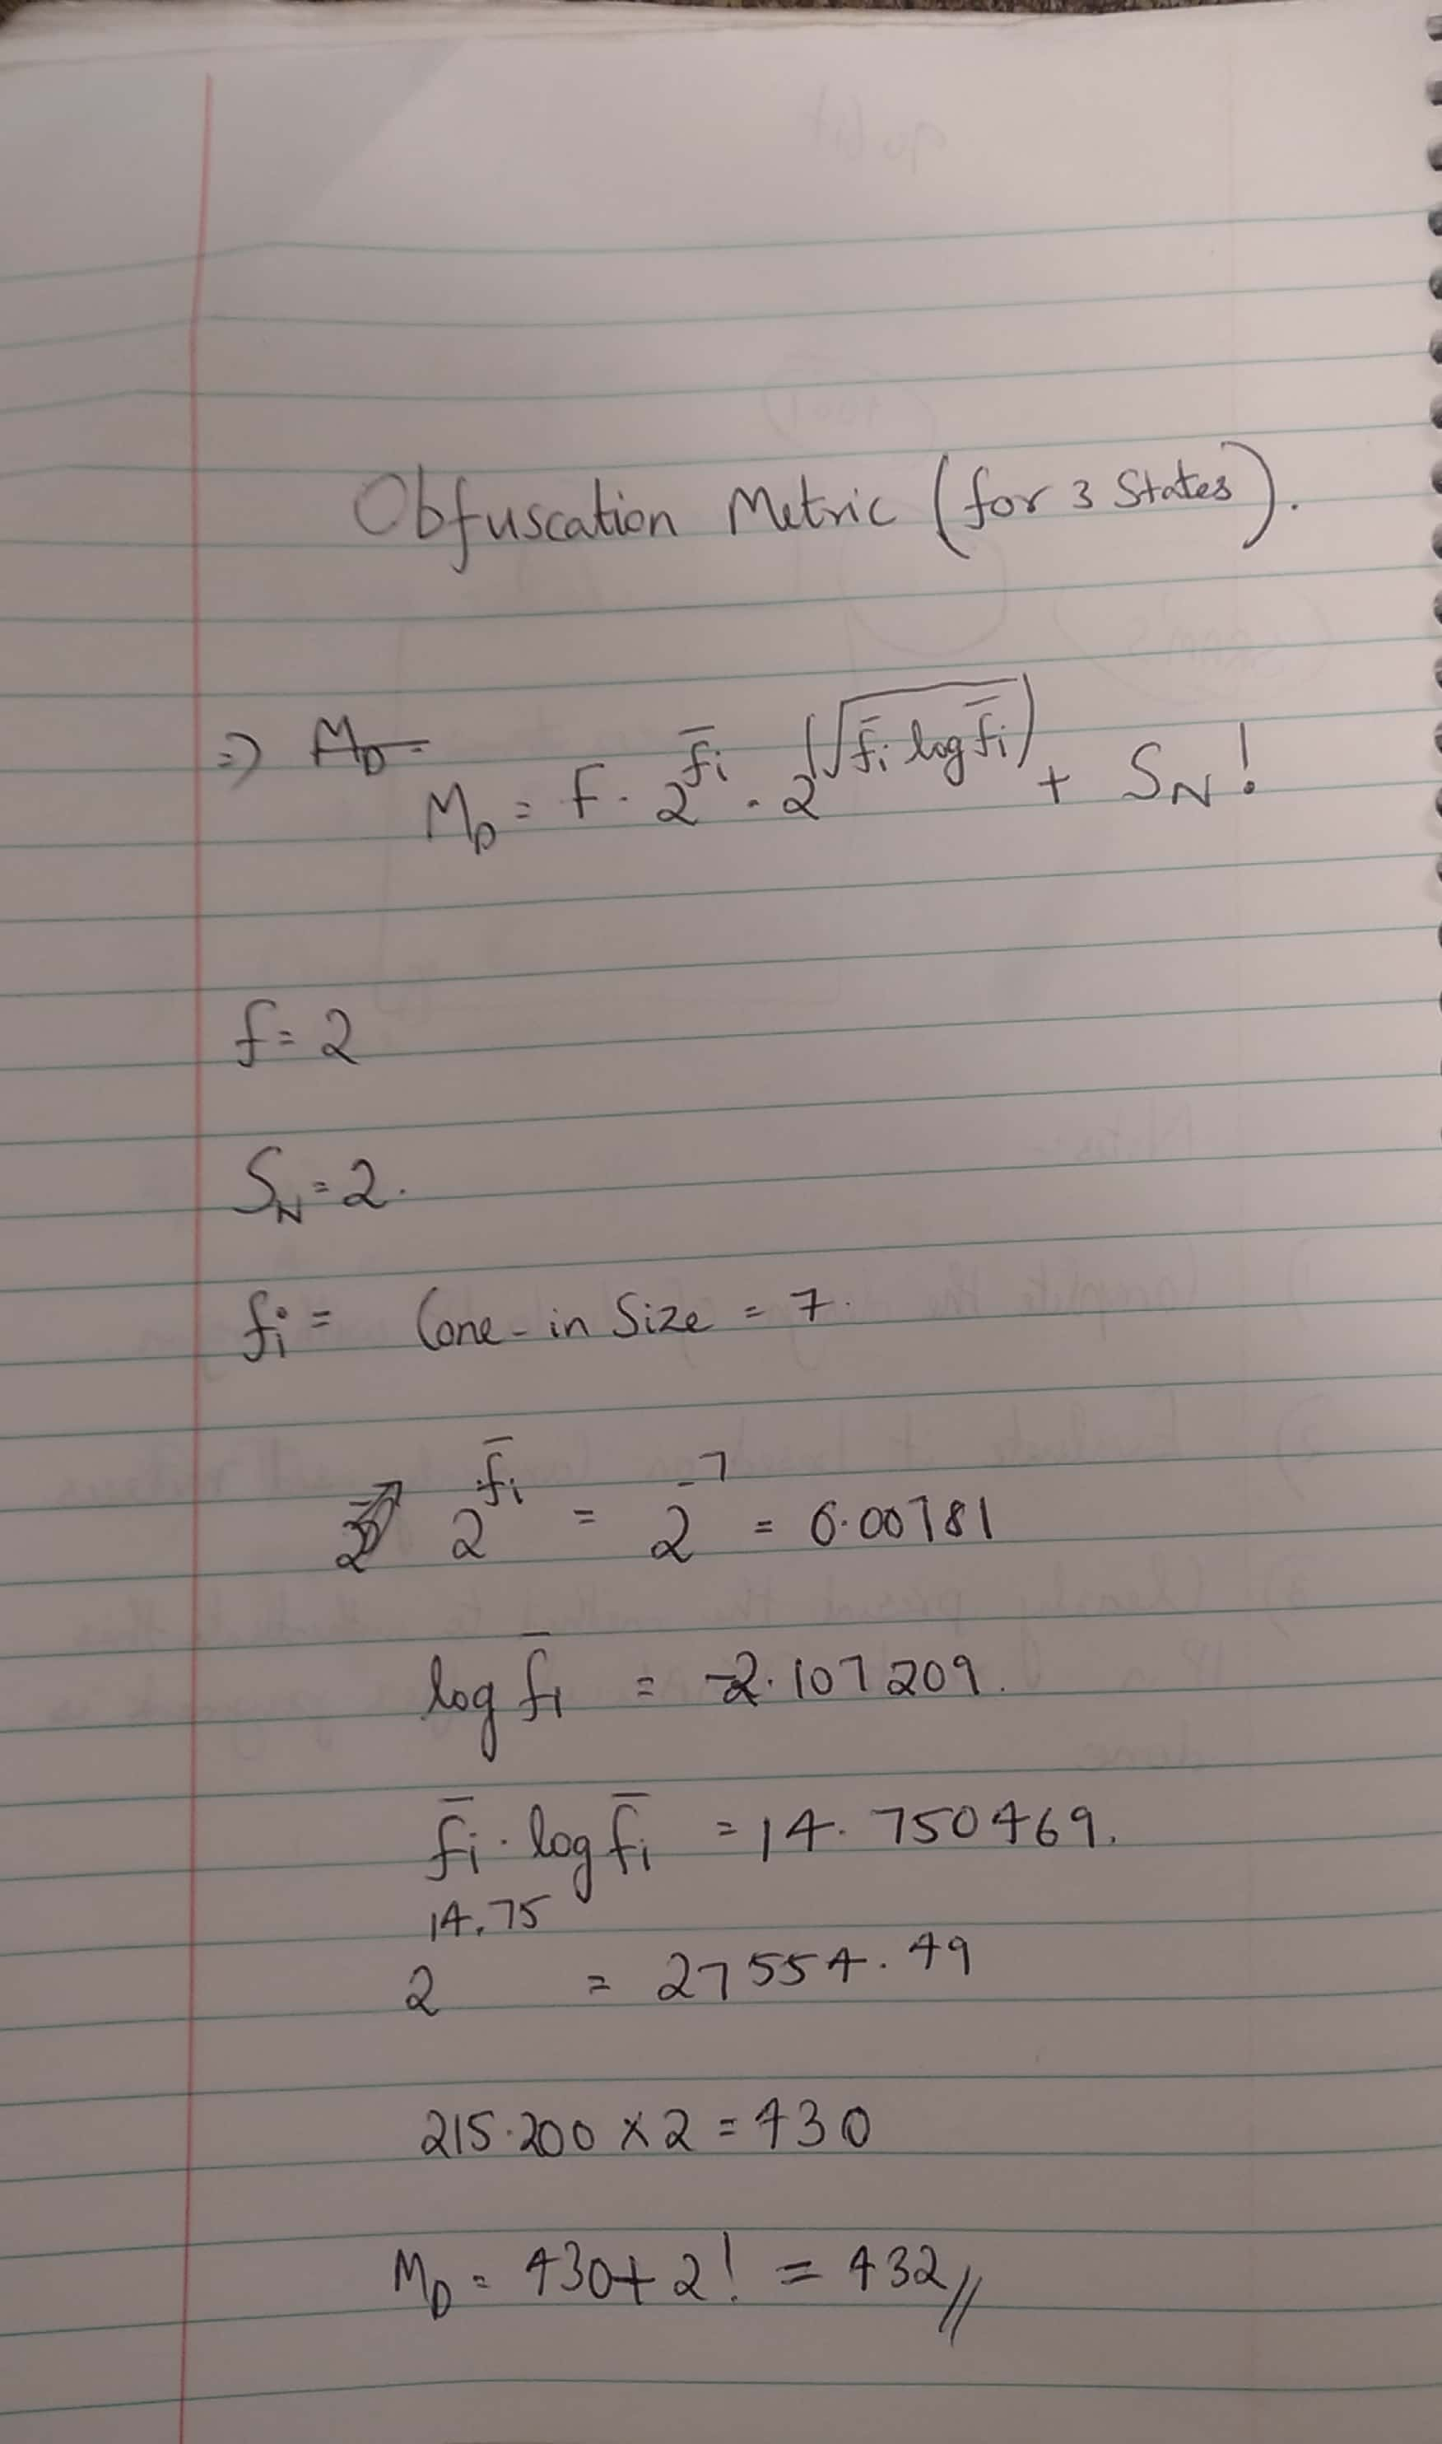

We are getting an obfuscated metric level of 432 when considered for 3 states. If we increase the number of states then the obfuscated metric value goes lower and it will enhance in good security strength.